RUSSIAN MODERNISM (1890-1934)
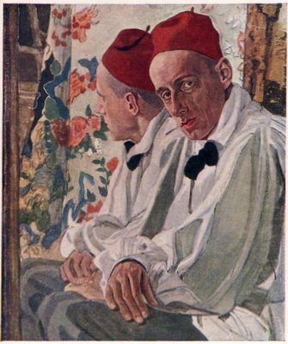
Russian modernism arose as a rejection of positivism and the realism of the major nineteenth-century Russian novelists such as Lev Tolstoy, Fyodor Dostoevsky, and Ivan Turgenev. In its first phase it was marked by a rekindled interest in poetry, mysticism and symbolism. There was also a tendency to seek a fusion of different forms of artistic expression: poetry, music, painting and theatre. Playwrights reflected the move away from naturalism towards the theatricality of commedia dell’arte and metadrama (the play within the play). In prose there emerged a new decorative style and new themes such as sexuality. The Russian Revolution of 1917 signalled an important shift towards the avant-garde. Poets adopted radical new poetic forms, glorified the new machine age or hearkened back to the pre-historical roots myth and experimented with invented, abstract language. Prose writers shifted towards a stark new factual style that incorporated documents and slogans. Their themes were the revolutionary changes in Russia and their own inadequacy in the face of the new Soviet man. The avant-garde received its death-blow with the promulgation of socialist realism as the mandatory style for all publishing authors at the All-Union Writers’ Conference in 1934.
Portrait of Vsevolod Meyerhold as Pierrot by Aleksandr Golovin, 1917.
DEFINITION
The term “modernism” has only become current in Russia since the end of the USSR; previously, the term was Decadentism, reflecting the Socialist Realist interpretation of literary history, which was enforced inside the Soviet Union as of 1934. Emigré criticism used the term Silver Age to describe the work of the first generation of modernist Russian poets. In present-day Russian parlance the term modernism is generally used to denote the period in the evolution of literary art between the dominant realist narrative mode of the nineteenth century and the avant-garde of the 1910s and 20s. In this article the term modernism is used as an internationally accepted umbrella term for the work of Symbolist, Futurist, Acmeist and other avant-garde poets, playwrights and prose-writers appearing in the years between about 1890 and 1934.
SYMBOLISM
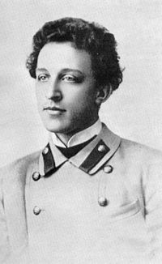
The earliest manifestation of modernism in Russian literature can be found in the works of Dmitry Merezhkovsky (1865-1941). Merezhkovsky rejected the ‘vulgar utilitarian realism’ of the preceding generation of Russian writers and bewailed the mediocrity of contemporary literary standards. He proposed a new art based on mysticism and the symbol. His own poetry was imbued with a fin-de-siècle pessimism. His religious aspirations were inspired by the writings of Dostoevsky and Vladimir Soloviev (1853-1900), who rejected positivism and proposed a new, mystical renewal of Christianity. Merezhkovsky and his wife, the poet Zinaida Gippius ,(1869-1945) were active in the search for a “New Church” and organised Religious-Philosophical Meetings where among other things the ideas of a “Godman,” originally proposed by Soloviev were discussed. The first generation of Symbolist poets, including such major figures as Konstantin Balmont (1867-1942) and Valery Briusov (1873-1924), were strongly influenced by the French Symbolists, especially Baudelaire, Verlaine, and Mallarmé, who began to be translated in the 1890s. Russian Symbolist poetry was characterized by a preoccupation with new poetic forms; themes of loneliness and pessimism dominated, as well as a mystical belief in an ideal other world summed up in the phrase a realibus ad realiora (“from reality to the more real,” Latin).
Photograph of symbolist poet Aleksander Blok, 1907.
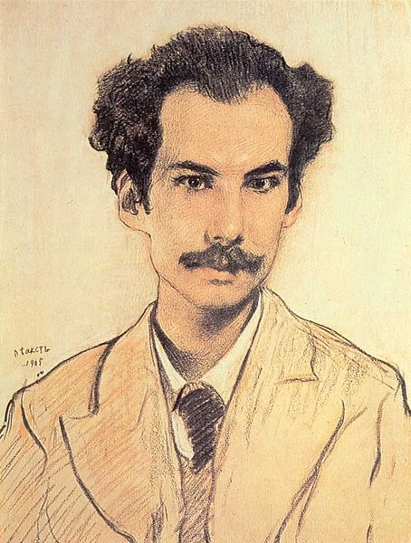
These themes were developed further in the poetry of the younger Symbolist Alexander Blok (1880-1921), which evoked the theme of a feminine ideal, expressed in the title of his first collection of poems Poems About the Beautiful Lady (1904). In what is the most famous poem of Russian Symbolism ‘The Stranger’ (1906) the woman appears to the poet as he drinks in a tavern. In Blok’s poetry the religious mysticism and pessimism began to acquire apocalyptic tones as the poet sensed the coming disasters of the twentieth century. This note was perhaps best expressed in the line “We are the children of Russia’s terrible years” from a 1914 poem. Russian Symbolism is represented by a whole pleiad of other first-rate poets, including Fyodor Sologub (1863-1927), Andrei Bely (1880-1934), and Vyacheslav Ivanov (1866-1949). The Symbolist period in Russia in represented by several important journals, which published original literary and critical works. The most important of these was the literary journal The Scales (1904-1909) and World of Art (1898-1904), which was a general cultural journal.
Portrait of Andrei Bely by Leon Bakst, 1904.
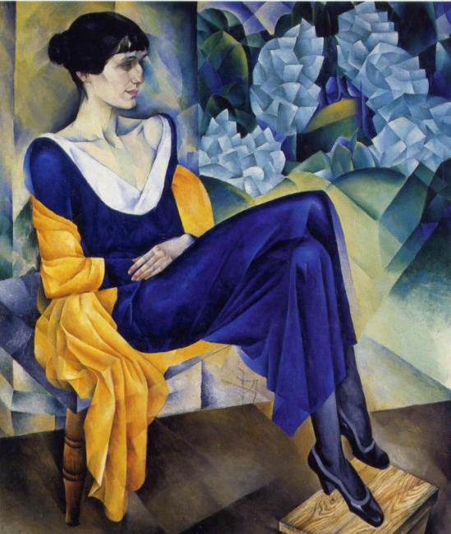
It was during the Symbolist period that another characteristic of Russian modernism became apparent, namely syncretism, or the tendency of various strands of artistic expression to come together – poetry, painting, music, and theatre, in the spirit of Richard Wagner’s Gesamtkunstwerk (German: “total work of art”). Russian proponents of syncretism included the composer Aleksandr Scriabin (1872-1915) and painter Vassily Kandinsky (1866-1944). An example of syncretism is the 1906 production by Vsevolod Meyerhold (1974-1940) of Blok’s short play The Showbooth, in which Meyerhold himself played the principal role of Pierrot. The decorations were by Nikolay Sapunov (1880-1912) and music by Mikhail Kuzmin (1875-1936). If, however, Wagner and his Russian followers sought a mystical unity between stage and audience, Meyerhold’s production evoked a scandal equalled only by the first staging by the Ballets Russes in Paris in 1913 of Le Sacre du Printemps (The Rite of Spring) by Igor Stravinsky (1882-1971). Inspired by the Italian comedy of masks, the playwrights Kuzmin and Nikolay Evreinov (1879-1953) experimented with play-within-a-play texts. Evreinov espoused the idea of the world as theatre, and his play The Main Thing (1921) can be compared to Luigi Pirandello’s Sei Personaggi in Cerca D’Autore (Six Characters in Search of an Author, 1920).
Portrait of Anna Akhmatova by Natan Altman, 1914.
By about 1910 Symbolism began to be surpassed by a new generation of poets, principally Nikolay Gumilev (1886-1921), Anna Akhmatov, 1889-1966) and Osip Mandelstam (1891-1938), who, inspired by the older poet Innokenty Annensky (1855-1909), focussed on the realia of life and espoused a clarity of expression and form in their work, which they called Acmeism. Blok and Briusov joined the Bolsheviks after the 1917 revolution. Blok wrote a haunting evocation of revolutionary Petrograd in his poem “The Twelve” (1918) in which twelve Bolshevik sailors patrol in a blizzard accompanied by a hungry dog and preceded by Jesus Christ. After the revolution many of the Symbolists emigrated; Symbolist and Acmeist tendencies were continued outside Russia in the poetry of Vladislav Khodasevich (1886-1939) and Georgy Ivanov (1894-1958), who produced his best work there.
THE AVANT-GARDE
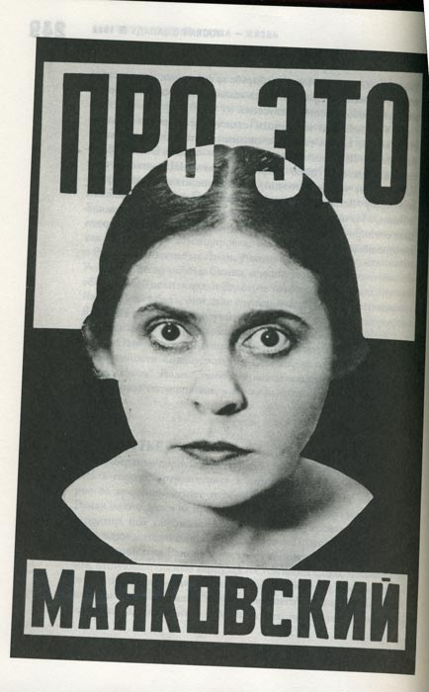
From about 1910 the Futurists Vladimir Mayakovsky (1893-1930) and Velimir Khlebnikov (1885-1922) initiated a radical break with Symbolism and Acmeism, experimenting with new forms of expression and, in the case of Khlebnikov, a new abstract, ‘trans-sense’ language. Sometimes called ‘cubo-futurism’ this movement was Janus-faced, looking forward to the excitement of cities and the machine age, and backwards to a primitive, pre-historic past. If the Symbolists had defiantly labelled themselves as ‘decadents’ and rejected the idea of social usefulness in favour of ideal aesthetics, the avant-garde openly welcomed the coming destruction of the old world and envisioned a new utopia. If the Symbolists had sought a renewal of poetic form, the avant-garde’s work was characterised by dissonance, isolation of objects from their context, and a rejection of narrative continuity.
Photo montage cover to Mayakovsky’s poem “About This” by Aleksandr Rodchenko, 1923.
In the 1910s Boris Pasternak (1890-1960) and Marina Tsvetaeva (1892-1941), in their individual ways, also emerged as major poets, Pasternak privileging metonymy over metaphor, as the linguist Roman Jakobson pointed out, while Tsvetaeva pushed the expressiveness of language and rhyme to the extreme. The two poets, who corresponded regularly, attempted to stand aside from the cataclysmic events in Russia, a stance summarized in a line from Pasternak’s poem “My Sister Life”: “What millennium is it outside?” Tsvetaeva emigrated to France in 1922, where she suffered from isolation from the émigré community. In 1939 she returned to Russia and committed suicide in 1941. Pasternak remained in the Soviet Union throughout his life, although threats were made to revoke his citizenship following the Nobel Prize scandal of 1958, when Pasternak first accepted and then refused the prize. Coming on the heels of the ‘illegal’ publication of his novel Doctor Zhivago by numerous foreign publishing houses, the award of the Nobel Prize and Pasternak’s coerced refusal of the honour was a huge embarrassment for the Party leadership.
The avant-garde tendency in Russian art, of which the Futurists were the poetic harbingers, straddled the Bolshevik revolution of 1917. Apart from poetry it encompassed Meyerhold’s constructivist theatre productions; the artists Kazimir Malevich, Mikhail Larionov and Vladimir Tatlin underwent a rapid evolution from Cubism through Rayonnism to abstract forms in painting, photography, cinema, and even architecture. If the Cubist art of the 1910s had had as its core procedure the presentation of an object from diverse perspectives, in the 1920s it is the collage principle - the juxtaposition of observed or found fragments – that dominated, whether in the photo-collages of Alexander Rodchenko, the new techniques of cinematic montage of Vsevolod Pudovkin, Sergei Eisenstein and Dziga Vertov or, as Patricia Carden has shown, in the prose of Isaac Babel (1894-1940).
MODERNIST PROSE
Due to the enduring popularity of naturalist prose, Russian modernist prose, in the early years, took a back seat to poetry and theatre. The novels of Alexei Remizov (1877-1957) showed a tendency to ornamentalism and delved into the roots of Russian folklore and medieval storytelling. The first truly Modernist novel was Petersburg (1916) by Andrei Bely, which deployed new forms of expression and poetic prose and has been compared to Joyce’s Ulysses. Prose in the 1920s was, on the one hand, inspired by the avant-garde tendency towards documentary and ‘factography’ – the pasting together of found texts - and by the technique of skaz, a mimicking of the common speech. The novel The Naked Year (1922) by Boris Pilnyak (1894-1938) combines these techniques; moreover, it renounces both a strong plot line and central characters. Babel’s short-story cycle Red Cavalry (1926) also uses montage techniques and skaz (the imitation of oral speech), but at the same time introduces and problematizes the role of the intellectual in revolutionary Russia. His other works include the cycle Odessa Stories (1931) about Jewish life in Odessa, and two plays, Sunset (1927) and Maria (1935). Yury Olesha (1899-1960) developed further the topic of individual inadequacy in the face of the new revolutionary man in his novel Envy (1927). In the 1920s the poets Mandelstam and Pasternak both published prose works. Konstantin Vaginov (1899-1934), author of Goat Song (1927) began writing poetic prose that can be compared to that of James Joyce in its ironic attention to everyday detail. The ultimate culmination of this line of development is the prose of Andrei Platonov (1899-1951), which subtly reflects official jargon and the hapless clichés of Russians left behind by the changes in their country.
As the 1920s progressed the political situation became increasingly hostile to the avant-garde. Mayakovsky’s suicide in 1930 was a harbinger of things to come. The promulgation of Socialist Realism at the All-Union Writers’ Conference in 1934 marked a definitive end to modernism in all forms of art, although Boris Groys has argued that socialist realism is a logical outgrowth of the avant-garde. Russian modernist artists were dispersed and in many cases (Babel, Meyerhold, Mandelstam) physically liquidated. Two of the survivors, however, produced important late examples of modernist writing: Anna Akhmatova’s Poem Without a Hero and Boris Pasternak’s Doctor Zhivago, both begun in the 1940s but published only much later. Modernism’s achievements also lived on to a considerable extent in the Russian novels of the émigré Vladimir Nabokov (1899-1977), notably Invitation to a Beheading (1935). It is only since the fall of Communism that many of the artists and works mentioned above have received full recognition in their homeland. Some critics have seen Russian postmodernism, which appeared in the 1980s, as in part an extension of the interrupted modernist aesthetic.

J. Douglas Clayton
University of Ottawa

References and Further Reading
Selected Secondary Sources
Barta, Peter and Ulrich Goebel. The European Foundations of Russian Modernism. Lewiston: E. Mellen Press, 1991. A specialised volume focusing mainly on links between modernist texts and German literature.
Carden, Patricia. The Art of Isaac Babel. Ithaca: Cornell University Press, 1972. A thorough, readable analysis of Babel’s works.
Donchin, Georgette. The Influence of French Symbolism on Russian Poetry. Gravenhage: Mouton, 1958. A careful study of the issue, requiring a knowledge of French poetry.
Gibian, George and H.W. Tjalsma. Russian Modernism: Culture and the Avant-Garde, 1900-1930. Ithaca, NY: Cornell U P, 1976. This collection of essays is a highly readable and useful source on Russian modernism.
Groys, Boris. The Total Art of Stalinism: Avant-Garde, Aesthetic Dictatorship, and Beyond. London: Verso Books, 2011. A classic analysis of Stalinist policy in the arts, relates only peripherally to Russian modernism.
Markov, Vladimir. Russian Futurism: A History. Introd. Ronald Vroon. Washington, DC: New Academia, 2006 (1968). A somewhat specialised but expert study of a single aspect of avant-garde poetry.
Selected Translations into English
Akhmatova, Anna. Selected Poems. Ed. and trans. Walter Arndt, Robert Keball and Carl Proffer. Ann Arbor, Mich.: Ardis, 1976. Contains a good selection of the poetry, including the Requiem cycle about the terror and Poem without a Hero.
Bely, Andrei. Petersburg. Trans., notes, and introd. Robert A. Maguire and John E. Malmstad. Bloomington : Indiana University Press, c1978. This classical annotated translation of the novel is the entry point for a study of Bely’s prose.
Blok, Aleksandr. Selected poems. Trans. Jon Stallworthy and Peter France. Manchester: Carcanet, 2000. One of the few collections of Blok’s poetry in English.
Bulgakov, Mikhail. The Master and Margarita. Trans. Diana Burgin and Katherine O’Connor. Dana Point, CA: Ardis, c1995. The most readable and authoritative translation of the novel of the six published to date.
Pasternak, Boris. Doctor Zhivago. Introd. Richard Pevear. Trans. and Notes Richard Pevear and Larissa Volokhonsky. New York: Vintage Classics, 2011. This translation supersedes that done by Max Hayward and Manya Harari in three weeks when the novel first appeared.
Pilnyak, Boris. The Naked Year. Ann Arbor: Ardis, 1975. This is the only translation of an important novel about the revolution.
Platonov, Andrei. The Foundation Pit. Trans. Robert and Elizabeth Chandler, and Olga Meerzon. Afterword and notes Robert Chandler and Olga Meerzon. New York: New York Review of Books Classics, 2009. The latest attempt to render into English the subtleties of this master of Russian prose.
Vaginov, Konstantin. Goat Song. Annotated Trans. and afterword Chris Lovett. http://www.nnnonline.org/vaginov/ A unique translation of a rare masterpiece with helpful hyperlinks to explanatory notes.

Source URLs for visuals
Fig. 1. Mikhail Vrubel. Valery Bryusov. 1906
http://ru.wikipedia.org/wiki/%D0%A4%D0%B0%D0%B9%D0%BB:Vrubel_Bryusov.jpg
Fig. 2. Leon Bakst. Andrey Bely. 1904.
Fig. 3. Aleksandr Golovin, Meyerhold as Pierrot. 1917
http://images.yandex.ru/yandsearch?text=%D0%B3%D0%BE%D0%BB%D0%BE%D0%B2%D0%B8%D0%BD%20%D0%BF%D0%BE%D1%80%D1%82%D1%80%D0%B5%D1%82%20%D0%BC%D0%B5%D0%B9%D0%B5%D1%80%D1%85%D0%BE%D0%BB%D1%8C%D0%B4%D0%B0&img_url=3.bp.blogspot.com%2F_vYPIDwOMhm4%2FSbjIVNdsMjI%2FAAAAAAAAYpE%2FQti_eagjWE0%2Fs400%2F09-03-091.jpg&pos=1&rpt=simage&noreask=1&lr=10114

Fig. 4 Natan Altman. Portrait of Anna Akhmatova. 1914

http://images.yandex.ru/yandsearch?text=%D0%B0%D0%BB%D1%8C%D1%82%D0%BC%D0%B0%D0%BD%20%D0%BF%D0%BE%D1%80%D1%82%D1%80%D0%B5%D1%82%20%D0%B0%D1%85%D0%BC%D0%B0%D1%82%D0%BE%D0%B2%D0%BE%D0%B9&img_url=img266.imageshack.us%2Fimg266%2F1446%2Fdvoe290.jpg&pos=0&rpt=simage&noreask=1&lr=10114

Fig. 5 Rodchenko: Front cover to Mayakovsky’s poem “About This.”
http://images.google.com/imgres?q=rodchenko+about+that&num=10&hl=en&biw=1024&bih=707&tbm=isch&tbnid=5KGgIp-dqtRwyM:&imgrefurl=http://foam.org/foam-amsterdam/calendar/2010-exhibitions/rodchenko,-alexander-revolution-in-photography&docid=SWDu6NS8j2f9UM&imgurl=http://foam.org/media/253191/Rodchenko%252520Alexander%252520Cover%252520of%252520the%252520Book%252520About%252520That%252520by%252520Vladimir%252520Mayakovski%2525201923%252520C%252520Stepanova%252520Archive%252520Moscow%252520House%252520of%252520Photography%252520Museum_TopCarousselPortrait.jpg&w=315&h=436&ei=i3gJULfjOIiX6AGd7bCECg&zoom=1&iact=hc&vpx=197&vpy=309&dur=1822&hovh=264&hovw=191&tx=93&ty=120&sig=105523655911472788262&page=1&tbnh=134&tbnw=97&start=0&ndsp=17&ved=1t:429,r:7,s:0,i:97

